4 Ednam Road, Dudley, West Midlands DY1 1HL  www.dudley.gov.uk |  |  | 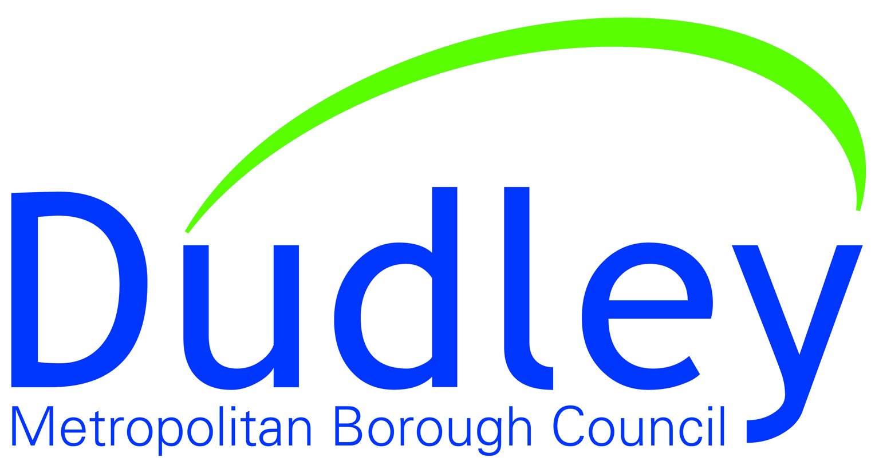

Dudley Towns Fund

(Virtual) Board Meeting

17 September 2021

Present

Board Members: Councillor Khurshid Ahmed; Hugh Burton; Corin Crane; Traci Dix-Williams; Rob Ellis; Derek Grove; Andrew Lovett (Chair); Helen Martin; Neil Thomas; and Amanda Tomlinson.

In Attendance

Samantha Bright; Kieran Casey; Jim Cunningham; Andy Field; Bill Kirk; Louise Phipps; Jack Stevens; and Jo Turner (minutes).

1 Apologies for Absence

Apologies were received from Board members Councillor Simon Phipps and Katherine Sheerin.

2 Declarations of Interest

Derek Grove declared that Dudley Zoo holds the lease for part of the land that the new building will be situated on.

3 Minutes of Last Meeting

RESOLVED: That the minutes of the last meeting held on 15 January 2021 be approved as a correct record.

4 Matters Arising

It was noted that comments on the draft Town Improvement Plan had been received and the plan submitted.

5 Stage 2: Towns Fund Application Process, Update on Progress

Following the formal offer of funding, made in person by Robert Jenrick MP (Secretary of State for Housing, Communities & Local Government) on 15 July, Helen Martin detailed the next steps: agreeing the Heads of Terms; finalising the programme and costs; and preparing the full business case, to be submitted by the end of 2021.

The Board noted the ongoing land requisition negotiations with properties adjacent to the Dudley Hippodrome and that offer letters had been prepared. The Board were reassured that a Compulsory Purchase Order had been considered, if appropriate, in terms of programme and timescales.

Neil Thomas shared some visuals of the University Park and updated on the building design works.

It was noted that the first of a series of workshops will take place in October for stakeholders and the local community, to discuss the function of the building and community use with a focus on health. Details of the workshops will be shared with the Board.

RESOLVED: That the Chair invite Michael Gove MP (new Secretary of State for Levelling Up, Housing & Communities) to visit.

6 Planning Application

Helen Martin provided an update on the planning application, including an overview of the support and objections received.

RESOLVED: That Helen Martin provide the Board with a summary of the planning objections received.

7 Programme and Risk Register

Andy Field presented the latest Programme and Risk Register, which will be shared with the Board.

Key risks were discussed, including funding, land acquisition, planning approval, and timescales. The Board were reassured that the funding gap was being addressed through value engineering, alternative funding and procurement processes, but concern was raised about reporting.

8 Levelling-Up Fund, Application & Other Dudley Town Centre Projects

Helen Martin briefed the Board on other levelling-up projects, including in Lye, Halesowen, Brierley Hill and Dudley Town Centre. Funding bids for these were being worked up, with consultant support.

It was agreed that the Board have an oversight of these projects.

9 Board Membership

The Chair proposed a review of Board membership, to ensure a strategic focus for Stage 2 and to link with other levelling-up projects.

RESOLVED: That the Chair review membership of the Board and the Terms of Reference, and present proposals at the next meeting.

10 Any Other Business

RESOLVED: That Helen Martin review the suitability of the proposed width of footpaths for the new development.

11 Date, Time & Format of Next Meetings

The next meeting of the Dudley Towns Fund Board is scheduled for 12:00pm on Friday 17 December. This will be held in-person at the new Institute of Technology.

