4 Ednam Road, Dudley, West Midlands DY1 1HL  www.dudley.gov.uk |  |  | 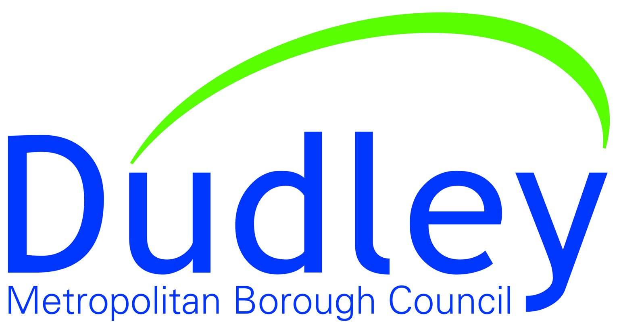

MINUTES

Meeting title | Brierley Hill Town Board
Date & time | Friday 23rd February 2024 at 10am
Venue | MS Teams
Invitees | Tim Sunter – Chair  Helen Martin – Dudley MBC  Mark Clarke - Dudley MBC  Jayne Pilkington – Dudley MBC  Neil Thomas – Dudley College  Mike Wood MP  Paul Hunt – Higgs LLP  Clive Skidmore – Property Owner  Shane Birch-Bastock – Business Owner/Brierley Hill Traders  Councillor Adam Davies  Councillor Wayne Little  Councillor John Martin  Frank Chamberlain - Project Manager Brierley Hill Community Programme  Marilyn Grazette – Transport for the West Midlands  Sam Cohen – Evolve Estates  Jonathan Poole – Savills  Andy Gray – Dudley CVS  Clare Waldron – Dudley MBC  Steve Bridgewater – Brierley Hill Market  Emma Atkins – Dudley MBC

- Declarations of interest not already declared

None.

- Apologies

Balvinder Heran, Marilyn Grazette, Steve Bridgewater, Jonathan Poole, Emma Atkins, Sam Cohen, Councillor Wayne Little, Paul Hunt.

- Minutes of the previous meeting

The Minutes were approved as an accurate record.
- Any matters arising not otherwise on the Agenda
There were no matters arising.

- Levelling Up Round 3

In November the Government announced that Brierley Hill had been successful in securing £20m in round three of Levelling Up Funding. The Council have submitted an updated project Validation Return to the Department for Levelling Up.

Since the original submission, the cost of delivery for the Transport Technology Centre has increased due to building costs. It is intended to meet these additional costs by the re-allocation of funds from within the programme. Discussions have been held with Transport for West Midlands. The proposed footpath cycleway connection to Merry Hill will now be combined with the Midlands Metro viaduct.

Daniels Land – Discussions had been held with WMCA over the strategic acquisition of the sites to support the delivery of strategic transportation and regeneration activity. Following a request from the Council, WMCA has established a Project Steering Group to review the future approach to the assets. This includes Transport for West Midlands, Homes England, DMBC and the Canal and River Trust. A meeting has been arranged with Sovereign Centro to review its intentions for the sites.
- Future High Streets

Project Managers have been appointed to take the work forward – it was noted that all contracts had to be let by September 2024 and projects delivered by March 2025.
Moor Centre –There is an allocated sum of up to £150,000 investment for Evolve Estates to 50% match fund and a decision on whether to proceed on the precinct works is to be decided by Evolve Estates by the end of February.

Changing Places Toilet - There is currently a review of the location and a preferred site is adjacent to the Metro Terminus. However, this will depend on the timescale for the delivery of the Metro as the funding needs to be committed by September 2024 and the grant fully spent by March 2025. It was noted that other locations available within the spend timescale are limited.

- Metro Business Case Progress

Carried forward for discussion at the next meeting as representative was not in attendance.

- Heritage Action Zone / Public Realm

The Board were informed of resurfacing, lining and signage that is to take place for all key streets between 2nd – 23rd April, 7pm-5am. Comms for this will go out shortly.

It was noted that TS thanked all those involved for all of the work that has been done.
Cultural Programme – work continues with projects having been delivered or close to completion. This includes the Brierley Hill Institute and working with CAPA, hoardings and art work will be put around the building while work continues to stress that it is business as usual.

- The Phoenix Project

Funded by the Arts Council, the Phoenix Project is now up and running. Working with Wildworks, a landscape theatre company, who will lead on this project for Brierley Hill. Looking for local creatives to be chosen for paid roles by learning.

Dudley College have hosted an event for Holocaust Memorial Day.

The College also has an exhibition at Dudley Archives. Produced by photography students, a series of portraits of current refugees living in the borough.
https://www.expressandstar.com/news/local-hubs/dudley/2024/02/08/refugees-in-dudley-are-celebrated-by-students-at-the-towns-college-in-new-exhibition/

- Terms of Reference Review

Terms of Reference are now required to be reviewed and updated. Noted for the next meeting after the local elections.
Action: MC to circulate current Terms of Reference for information.

- Any Other Urgent Business

Cllr Davies raised the issue of bin bags left in the High Street. He has had previous conversations with the Waste Operations Manager, who was looking into a solution.
Action: JP to follow up.

Cllr Davies – Elements of a TRO.
Action: JP to speak to Mark Bagnell/Steve Cooksey.

- Date of Next Meeting – Friday 17th May at 10am.

