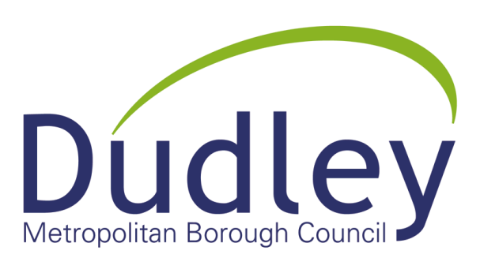
Community Engagement Strategy

CAPA officer: Clare Marshall/Samantha Bright

Lead officer: Helen Martin

Subject: Mobilising marcomms for Town Board’s bid

Date: April 2020

Background

The Dudley Town Board is responsible for owning the Strategic Vision for Dudley and will ensure that a well evidenced, competitive and compelling Investment plan is developed, and delivered.

The Council has been allocated £173,000 of Development Funding to be used to develop the Dudley Town Board’s Investment Prospectus which will be submitted to the Government’s Towns Fund.

It is Governments intention that the capacity resource be used in order to;
• Convene a Town Deal Board by January 2020. (Dudley established a Town Deal Board at the end of 2019).
• Run business and wider community engagement events
• Develop Town Investment Plans by Summer 2020
• Provide technical expertise for business case development

The Vision

Dudley is an historic market town looking to the future. By 2030 it will be a town which
serves the needs of its local population and which remains the strong focus for civic life, for
town centre living, for shopping, tourism and heritage, leisure and education.

These are exciting times for Dudley. By 2023 we will have delivered the Metro and a major new transport interchange in the heart of the town. This significant investment will set a new context for development and regeneration of our town centre and the wider borough. It will offer potential to intensify land uses and provide more homes close to commercial uses, especially retail, that need regular patronage to prosper. In order to optimise the potential of the town centre, the Council and its public partners are investing in the town and seeking to engage with developers and investors who share our passion to deliver high-quality change through world-class design and placemaking.

The ambition

- To accelerate housing delivery and improve the quality and choice of new homes, commercial and employment uses, leisure and retail provision.
- Facilitate and enable inclusive growth through provision of education, health, community facilities, jobs and skills.
- Create high-quality and healthy environments in order for residents, workers, businesses and visitors to thrive.

University Campus

The Board has agreed that the focus of our bid should be the development of a University Campus in Dudley.

Dudley Council and its Dudley North / Dudley South MP’s have long campaigned for an Educational Campus in the town and the success of Dudley College in securing resources for Institute of Technology Status provides the impetus to create a true learning campus in the heart of the town.

Dudley College propose that two further learning establishments be developed, adjacent to the planned Black Country and Marches Technology Institute as the key element of the Town Investment Plan. Further interventions will need to be planned for to link this investment into the wider regeneration activity and the town centre.

Officers and representatives of Dudley College have collaborated to produce an indicative spend plan for the capacity funding that allows the development of a full submission document whilst also giving enough certainty for a Higher Educational Institution to be secured prior to submission; strengthening the bid and the plans deliverability.

Require more info on the project to include benefits to the community etc.

Aim

To engage the local community in the Town Board bid project

Objectives

- To organise at least one face to face and one digital engagement event
- To create opportunities at each stage of the project for community input
- To utilise the marketing and communications strategy to communicate with different segments of the community

Community

Businesses
Frequent visitors/
Consumers

Faith groups

Market traders

Residents

Dudley community

There is a strong community feel in Dudley town centre made up of residents, market traders, businesses, regular visitors/consumers and faith groups. It is important that the community feels informed and included in changes and development in the town centre. This community engagement strategy will outline how we seek to do this successfully. It will also be complemented by a marketing and communications strategy which will seek to include and communicate to all segments of the community.

Engaging the local community prevents negative feedback and media coverage. It provides people with a sense of ownership and pride in their town centre and increases the likelihood of them engaging in future projects.

The people of Dudley know what they want from their town centre, and can provide valuable insight into what can be done to improve the look, feel and economy. Therefore, it’s important we engage the community throughout the process.

Community engagement

Community engagement is about creating a long-term and trusted two-way conversation with the community of Dudley town centre.

How we will engage:

INFORM | CONSULT
Communicate clearly and effectively throughout the project, using a variety of techniques catered to each segment. | We will undertake public feedback sessions which will include face to face, digital and accessible formats.
INVOLVE | RESPOND
We will create opportunities for the local community to be involved in all aspects from design to delivery. | There will be a clear line of communication for people to ask questions and express concerns about the project.

Action plan April 2020 to March 2021

Activities | When | Who
- To organise at least one face to face and one digital engagement event
Engage with the People’s Panel
Conduct online surveys
Utilise community groups
- To create opportunities at each stage of the project for community input
Create a timeline for the project
Identify areas of flexibility for community input
- To utilise the marketing and communications strategy to communicate with different segments of the community
Create strategy
Identify aims and objectives to complement this strategy
Align activity

Measuring success

We will review this strategy every quarter to ensure we are meeting the objectives and alter where needed. In 12 months we will look to update this strategy and report on how successful it has been.

We will do this by analysing:

- Media coverage
- Social media sentiment (positive comments/engagement)
- Public opinion (via feedback surveys, no. of complaints etc.)

