4 Ednam Road, Dudley, West Midlands DY1 1HL  www.dudley.gov.uk |  |  | 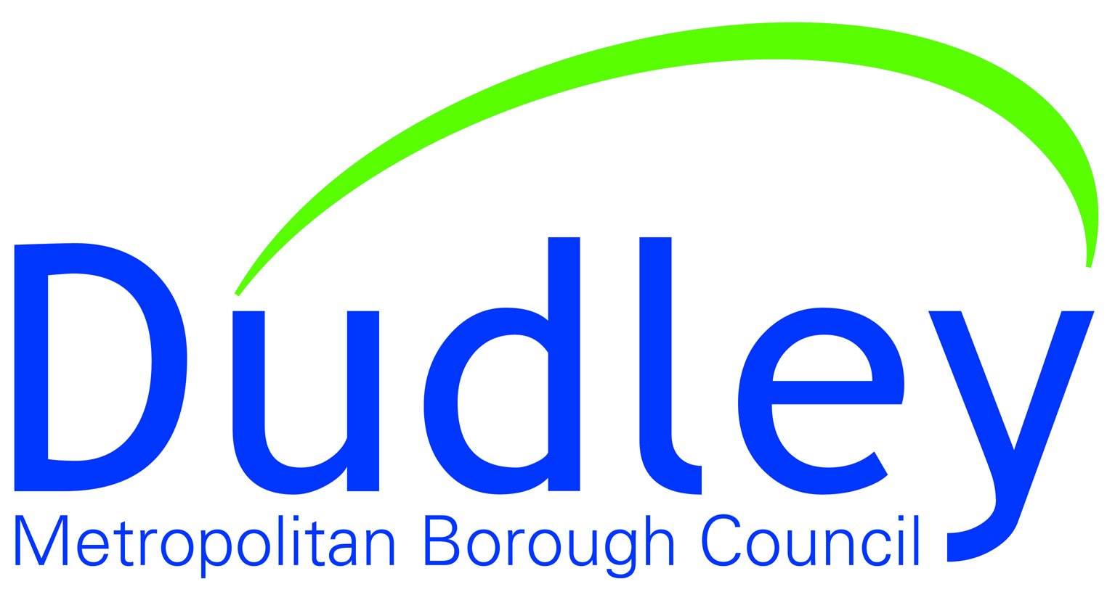

Agenda

Meeting Title | Dudley Towns Fund Board
Date & Time | 17 September 2021 at 1:00pm
Venue | via MS Teams
Board Members  Andrew Lovett (Chair)  Marco Longhi MP  Neil Thomas  Helen Martin  Stuart Everton  Amanda Tomlinson  Corin Crane  Nick Mallinson  Derek Grove  Councillor Simon Phipps  Councillor Khurshid Ahmed  Rob Ellis  Julie Nugent  Katherine Sheerin  Pete Bond  Hugh Burton  Traci Dix-Williams | Guest Attendees  Paul Brothwood  Councillor Patrick Harley  James Fleet  Clare Marshall  Samantha Bright  Bill Kirk  Phil Thomas  Vicky Smith  Steve Johnson  James Pearson  Jim Cunningham  Mick Donovan  Maria Salcedo, Amion  Sarah Middleton

1 Apologies for Absence

2 Declarations of Interest

3 Minutes of Last Meeting

4 Matters Arising

5 Stage 2 Towns Fund Application Process, Update On Progress

Verbal Report from Helen Martin

6 Planning Application

Verbal Report from Helen Martin

7 Programme and Risk Register

Verbal Report from Andy Field

8 Levelling-Up Fund, Application & Other Dudley Town Centre Projects

Verbal Report from Helen Martin

9 Board Membership

Verbal Report from Chair

10 Any Other Business

11 Date, Time & Format of Next Meetings

