

**Dudley Town Centre**

**Travel Survey**

**November 2019 - January 2020**

Human Intelligence Policy Strategy and Innovation, TfWM

**Synopsis**

**Travel patterns in the Dudley Town Centre Area**

* Overall, 58% regularly travelled through the Dudley Town Centre, 27% worked there, whilst 17% lived in the vicinity.
* A tenth (10%) travelled to study, whilst smaller proportions represented a business or travelled around the locality to worship (3% and 2% respectively).
* The majority were frequent travellers with three quarters (75%) travelling at least once per week. 13% travelled once per month and 12% less often.

**Work journeys made in the Dudley Town Centre Area:**

* Overall, 280 respondents made a work trip in the Dudley Town Centre area.
* 35% of respondents worked at Dudley College Campus. 29% for Dudley MBC and 4% for the NHS.
* Work journeys were typically made from the Wrens Nest, Woodsetton and Brierley Hill areas.
* Unsurprisingly, the majority of commuters were frequent travellers with 64% travelling 5 days + per week and an additional 29% 2-4 days a week.
* Car use dominated in terms of mode of travel with 63% travelling as a lone car driver and 10% in a shared car, however just over a fifth (21%) travelled by bus.
* Commuters were most likely to travel during the peak travel periods.
* Work journeys took on average 26 min: 02 sec, car sharers had the shortest journeys; bus users the longest.
* 58% of commuters allowed extra time for their work journey due to congestion, with lone car drivers most likely to do so.

**Education journeys made through the Dudley Town Centre Area:**

* 104 respondents made education trips in and/or around the Dudley Town Centre vicinity.
* Collectively, the vast majority of respondents (at 93%) were travelling to one of the Dudley College campuses.
* Just over a quarter (28%) of scholars travelled at least 5 days per week, over half (58%) 2-4 days per week and 14% once per week.
* Over three quarters (77%) of those travelling for education used bus services, just 8% equally were lone car drivers or car sharers.
* Scholars were most likely to make their trips during the morning peak period (67%, 08:00 to 09:30) or between 15:30 up to 18:00 (47%).
* On average education trips took 28 minutes: 31 seconds, a slightly lower average time to work trips.
* 58% of those travelling for education allowed extra time for their journey due to congestion.

**Religious journeys made through the Dudley Town Centre Area:**

* 20 respondents made religious trips in and/or around Dudley.
* Journeys for religious reasons were comparatively less frequent with 35% travelling 2-4 days per week and just 15% travelling for worship on a daily basis.
* Bus use and car sharing dominated in terms of modal share with (37% and 36% respectively). Equal proportions of 11% walked or were a lone car drivers.
* 63% of religious trips were made on Sundays, albeit significant proportions indicated they travelled on a weekday, with 42% travelling on weekdays between 09:30-16:00.
* Journeys for worship took on average 17 min: 17 sec, with bus users having the longest journeys.

**Journeys made travelling through the Dudley Town Centre Area:**

* Overall, 160 people solely made journeys though the Dudley Town Centre area (i.e. neither lived nor travelled to places in the locality but were driving through the area).
* 39% of respondents travelled through the area for work, 21% to visit friends/relatives and 10% for works business.
* Predictably, considering the almost half the sample were commuters, around a third (32%) travelled at least 5 days per week, with equal shares of 34% travelling 2-4 days per week or once per week.
* Car use dominated in terms of mode with 44% travelling as a lone car driver and 28% in a shared car. 23% travelled through by bus.
* Travelling through journeys hit a high amongst the off peak hours of 09:30 to 15:30 (44%) and the evening peak hours of 15:30 up to 18:00 (42%).

**Shopping/Leisure journeys made through the Dudley Town Centre Area:**

* Shoppers (48%, once a week or more) were more frequent users of Dudley Town Centre in comparison to leisure users (at 24%, weekly use).
* Collectively, shopper/leisure users largely travelled by car (53% leisure users; 51% shoppers), however, significant proportions travelled by bus (37% leisure users; 35% shoppers).

**Impact of the Dudley Town Centre Project Activity on Local Businesses:**

* 26 individual businesses responded to the survey.
* 64% stated that it would have a significant impact on their clients/customers.
* 50% felt the works would have a significant impact on their staff.
* 37% felt they would have a significant impact on the freight/logistics of their business/company.

**Willingness to Change Travel Patterns during the Project Activity**

* The behavioural change respondents were ***most***willing to make during the disruption was to *change the time of travel to avoid the peak* (28%).
* Albeit, a similar share (at 26%) would take a different route. Fewer were interested in *walking and/or cycling more (15%)* or *leaving their car at home* (11%).
* Re-timing was the most common behavioural change amongst travellers regardless of journey purpose with the exception of those who simply travel through the area who were most likely to re-route.
* In terms of mode of travel lone car driver were most likely to re-route, especially when commuting or shopping.
* Both bus users and car sharers were most likely to re-time their journeys, particularly for education trips and when shopping.
* The small subgroup of 78 respondents who would re-mode were most likely to transfer to bus (49%, 3% from the overall sample).

**Awareness of the Planned Dudley Town Centre Project Works**

* Dudley Town Centre users were most aware of the *planned Midland Metro extension* (80%), followed by *the* *Black Country Living Museum expansion,* the *new Dudley Leisure Centre* and the *Dudley Transport Interchange* (48%, 45% and 37% respectively).
* Around a quarter were mindful of the *new Institute of Technology (IoT) at Castle Hill* (26%), *Portersfield and the Very Light Railway and Innovation Centre at Castle Hill* (equally with 25%).
* Fewer were aware of the *Autonomous vehicles demonstrator route* (14%).

**Likelihood New Midland Metro Use**

* Around a three quarters (73%) of respondents stated that they would be likely to use the new Metro once the work is complete.
* Likelihood of Midland Metro use rose to 80% amongst bus users, dipping to 65% amongst lone car drivers.

**Information sources used to gain information about local journeys:**

* The internet/online was the most common source of travel information (62%), followed by Mobile Apps (34%), Facebook (31%) and local radio (24%).
* The internet was the most widely used source of information amongst all groups of users.
* Car users had higher levels of use of local radio (35%, lone car drivers; 28%, car sharers), whilst car drivers had greater levels of sat nav use (32%).
* Bus users had higher levels of use of mobile apps (47%), Facebook (35%) and Twitter (15%).

**Further Suggestions For Improvements To Journeys in The Dudley Town Centre Area:**

* 25% want to see *improved bus reliability and 18% higher frequency of bus services.*

**1.0 INTRODUCTION**

1.1 **BACKGROUND TO RESEARCH**

1.1.1 Commencing in 2020 and continuing over the following years Dudley Town Centre will be benefitting from more than £210 million investment. The major regeneration projects include plans for a Metro extension from Brierley Hill to Dudley, the erection of a brand new transport interchange, the construction of a Very Light Rail Innovation Centre, the Institute of Technology and an expansion at the Black Country Living Museum. The Portersfield site in Dudley Town Centre will also undergo major development, while changes and improvements to the road network will be due to take place.

1.1.2 In order to minimise the disruption caused by the regeneration project works and to effectively manage communications, Transport for West Midlands, working in partnership with Dudley MBC and the Midland Metro Alliance devised a travel survey. The survey was designed to help TfWM identify the most popular times and ways people travel around Dudley which will aid in the development of journey planning solutions and travel options for travel for Dudley Town Centre users while the development work is taking place.

**1.2** **SURVEY DETAILS**

1.2.1 The survey aimed to examine:

1. Respondent profile in terms of age, gender, car ownership and Mosaic profile.
2. Travel patterns of respondents who make journeys in and/or around the Dudley Town Centre area in terms of journey purpose(s), frequency of travel and mode(s) of travel.
3. Details of work journeys when travelling in the Dudley Town Centre area.
4. Details of education journeys when travelling in the Dudley Town Centre area.
5. Details of religious/faith journeys when travelling in the Dudley Town Centre area.
6. Details of shopping/leisure journeys when travelling in the Dudley Town Centre area.
7. Details of local businesses and how the Dudley project works may have an impact.
8. Potential behavioural changes during regeneration project works.
9. Awareness of the planned major projects around Dudley.
10. Likelihood of using the new Metro extension running from Grand Central Birmingham and Wolverhampton.
11. Preferred sources of travel information.
12. Suggested improvements to journeys in the Dudley Town Centre area.
13. **THE SURVEY**

2.1 **METHODOLOGY**

2.1.1 Respondents who use Dudley Town Centre were invited to take part in an online questionnaire. The survey was promoted via social media and the TfWM website*.* A link containing the survey was also sent directly to businesses and Sixth Form Colleges within the Dudley Town Centre vicinity. In addition Dudley MBC promoted the survey amongst staff members. The survey ran fromthe 8th November 2019, with an original closing date of the 16th December which was extended to the 10th January 2020 in order to cover the Christmas period. All completed questionnaires were eligible to be entered into a prize draw with one prize of £30 in either Amazon or High Street vouchers. A copy of the questionnaire can be seen in **Appendix 1**.

**Figure 1: Dudley Town Centre Area**

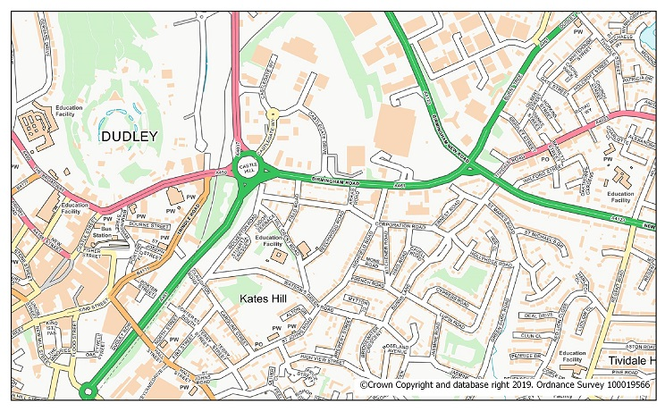

**3.0 RESULTS**

**3.1 SURVEY RESPONSE RATE**

3.1.1 Overall 1,075 valid surveys were completed by respondents who travelled in the Dudley Town Centre area. A sample of this size has a margin of error of +/- 2.8% at a 95% confidence level.

**3.2 RESPONDENT PROFILE**

3.2.1 **Table 1** summarises the profile of respondents to the survey in terms of age, gender and car ownership. In addition **Table 2** provides a breakdown of respondents Mosaic group on the basis of their home postcode. **See Appendices 2a and 2b.**

**Table 1: Respondent Profile**

*\*source 2011 census data*

|  |  |  |  |
| --- | --- | --- | --- |
| **Age** | **Respondents** | **%** | **WM Data\*** |
| 16-24 | 109 | 13 | 18 |
| 25-34 | 121 | 15 | 34 |
| 35-44 | 168 | 20 |
| 45-59 | 311 | 38 | 22 |
| 60 or over | 115 | 14 | 25 |
| Prefer not to say | 3 | 0 |  |
| **Gender** |  |  |  |
| Male | 338 | 41 | 49 |
| Female | 482 | 58 | 51 |
| Transgender | 7 | 1 |  |
| Prefer not to say | 1 | 0 |  |
| **Car ownership** |  |  |  |
| One | 373 | 37 | 69 |
| Two | 342 | 34 |
| Three or more | 126 | 12 |
| None | 175 | 17 | 31 |

* Travellers in the area were more likely to be from the economically active age groups between 25 - 59 compared to the West Midlands as a whole (73% v 56%) and less likely to come from the youngest and oldest age groups.
* Respondents were more likely to be female (58%) than male (41%).
* The sample was skewed towards car owners with over four fifths (83%) emanating from a car owning household compared to 69% in the West Midlands as a whole.

3.2.2 Mosaic UK classifies consumers in the United Kingdom into one of 15 groups on the basis of their home postcode. It provides an understanding of the demographics, life styles and behaviours of all individuals and households in the UK. **Table 2** looks at the profile respondents who use Dudley Town Centre.

* The top 3 Mosaic groups travelling in the area were *Aspiring Home Makers*, *Family Basics* and *Senior Security*.
* When comparing the profile of Dudley Town Centre users to the West Midlands as a whole there were more respondents than one would expect from the *Aspiring Homemakers* group.
* In contrast there were fewer respondents than one would expect from the *Urban Cohesion* group.

**Table 2: Key Mosaic Group Of Dudley Town Centre Users Compared To Mosaic Profile Of West Midlands**

|  |  |  |  |  |
| --- | --- | --- | --- | --- |
| **Mosaic Code** | **Mosaic Groups** | **Description** | **% sample** | **% WM** |
| **H** | Aspiring Homemakers | Aspiring Homemakers are younger households who have, often, only recently set up home. They usually own their homes in private suburbs, which they have chosen to fit their budget. | 18 | 11 |
| **M** | Family Basics | Family Basics are families with children who have limited budgets and can struggle to make ends meet. Their homes are low cost and are often found in areas with fewer employment options. | 15 | 13 |
| **F** | Senior Security | Senior Security are elderly singles and couples who are still living independently in comfortable homes that they own. Property equity gives them a reassuring level of financial security. This group includes people who have remained in family homes after their children have left, and those who have chosen to downsize to live among others of similar ages and lifestyles. | 11 | 10 |
| **K** | Modest Traditions | Modest Traditions are older people living in inexpensive homes that they own, often with the mortgage nearly paid off. Both incomes and qualifications are modest, but most enjoy a reasonable standard of living. | 10 | 7 |
| **N** | Vintage Value | Vintage Value are elderly people who mostly live alone, either in social or private housing, often built with the elderly in mind. Levels of independence vary, but with health needs growing and incomes declining, many require an increasing amount of support. | 9 | 11 |
| **E** | Suburban Stability | Suburban Stability are typically mature couples or families, some enjoying recent empty-nest status and others with older children still at home. They live in mid-range family homes in traditional suburbs where they have been settled for many years | 8 | 5 |
| **L** | Transient Renters | Transient Renters are single people who pay modest rents for low cost homes. Mainly younger people, they are highly transient, often living in a property for only a short length of time before moving on. | 8 | 8 |
| **O** | Municipal Challenge | Municipal Challenge are long-term social renters living in low-value multi-storey flats in urban locations, or small terraces on outlying estates. These are challenged neighbourhoods with limited employment options and correspondingly low household incomes. | 7 | 7 |
| **D** | Domestic Success | Domestic Success are high-earning families who live affluent lifestyles in upmarket homes situated in sought after residential neighbourhoods. Their busy lives revolve around their children and successful careers in higher managerial and professional roles. | 4 | 4 |
| **B** | Prestige Positions | Prestige Positions are affluent married couples whose successful careers have afforded them financial security and a spacious home in a prestigious and established residential area. While some are mature empty-nesters or elderly retired couples, others are still supporting their teenage or older children. | 4 | 5 |
| **I** | Urban Cohesion | Urban Cohesion are settled extended families and older people who live in multi-cultural city suburbs. Most have bought their own homes and have been settled in these neighbourhoods for many years, enjoying the sense of community they feel there. | 3 | 11 |

**3.3** **GENERAL TRAVEL PATTERNS WITHIN THE DUDLEY TOWN CENTRE**

3.3.1 **Journey purpose:** Respondents gave multiple reasons for travelling in and or around the Dudley Town Centre area. **See Appendix 3a.**

* As **Table 3** demonstrates, 58% regularly travelled through Dudley Town Centre, whilst 27% worked in the Dudley Town Centre area.
* Almost a fifth of respondents (17%) lived in the area.
* A tenth (10%) travelled in the area for education purposes.

**Table 3: Journey Purpose Summary And Detailed Responses**

*\*% exceed 100 due to multiple responses*

*Excludes those who never travel around the Dudley Town Centre Area*

|  |  |  |
| --- | --- | --- |
| **Journey Type Summary** | **Respondents** | **%\*** |
| I regularly travel through the Dudley Town centre area | 596 | 58 |
| I work in the Dudley Town centre area | 280 | 27 |
| I live in the Dudley Town centre area | 173 | 17 |
| I study in the Dudley Town centre area | 105 | 10 |
| I travel to the Dudley Town centre area for religious or faith reasons | 21 | 2 |
| I run/represent a business/ organisation in the Dudley Town centre area | 27 | 3 |
| Other | 140 | 14 |
| **Base** | **1032** | **131** |

3.3.2 **Frequency Of Travel**: Respondents were frequent travellers in the area with three quarters (75%) travelling once a week or more. Similar proportions travelled at least once a month or less often (13% and 12% respectively). See **Appendix 3b**.

* Those who work (93%) in the Dudley Town Centre area were the most regular travellers.
* Similar proportions of those who either lived in the Dudley Town Centre vicinity, travelled for worship (90% each), were scholars (88%) or represented a business (85%) were also weekly travellers.
* Weekly travelled dipped to 78% amongst those would travelled through the area, with this group more likely to travel on a monthly basis (15%).

**Figure 2: Frequency Of Travel Within Dudley Town Centre By Journey Type**

**3.4** **WORK LOCATION, COMMUTER TRAVEL BEHAVIOURS IN/AROUND DUDLEY TOWN CENTREAND EFFECT OF CONGESTION ON TRIPS**

3.4.1 280 respondents made a work trip in the Dudley Town Centre area, these respondents were asked to give more details about their journeys.

3.4.2 **Organisation:** Dudley Town Centre users named 42 different companies/sectors that they were making journeys to/from. **Table 4** summarises the main organisations/sectors that respondents worked for. **Appendix 4a** gives a full list.

* Perhaps due to the nature of survey distribution, employees from both Dudley College Campus and Dudley MBC made up a significant proportion of respondents (35% and 29% respectively). Following this were employees from the NHS (4%).

**Table 4: Key Organisations Responding To The Survey**

|  |  |  |
| --- | --- | --- |
|  | **Respondents** | **%** |
| Dudley College Campus | 98 | 35 |
| Dudley MBC | 80 | 29 |
| NHS | 12 | 4 |
| Other | 90 | 32 |

3.4.3 **Journey origin of work trips to Dudley Town Centre:** **Figure 3** provides a map of the journey origin of commuter trips.

* Commuters were largely travelling from the Dudley area; with significant proportions travelling from the DY3 Wrens Nest/Parks Hall and Woodsetton area and the DY5 Brierley Hill area.
* There were significant clusters travelling from the Netherton and Kingswinford areas, while the Sedgley/Upper Gornal areas were also popular journey origins.

**Figure 3: Home Postcode of Commuters**

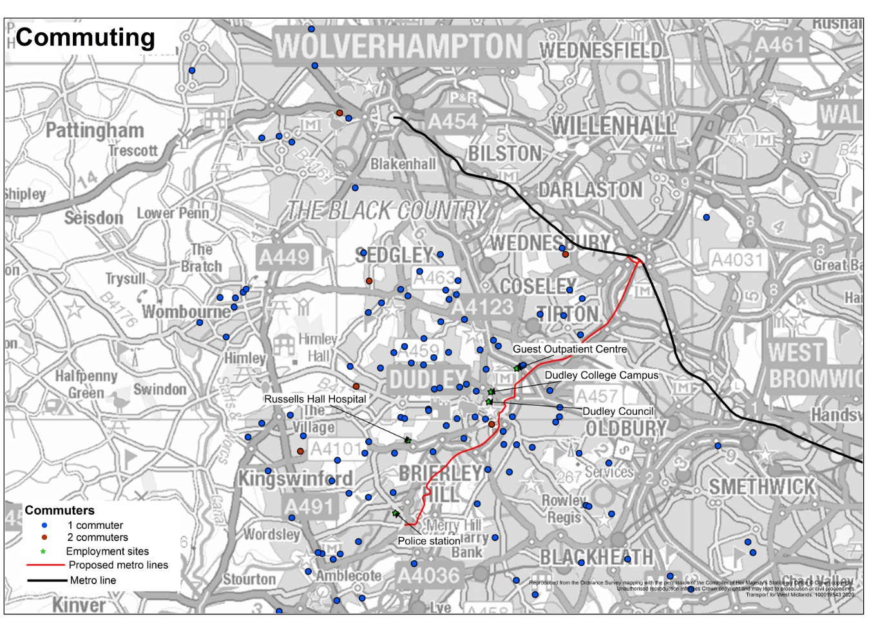

3.4.4 **Frequency of work journeys:** The majority of commuters travelled in the Dudley Town Centre area on a daily basis (64%) with an additional 29% doing so 2-4 days a week. 4% travelled once a week, just 1% monthly and 3% less often.

* Dudley College employees (at 73%) were more likely to be daily (5+ days per week) Dudley Town Centre users.
* As **Figure 4** and **Appendix 4b** demonstrate, a third (33%) of those working for the NHS travelled in the area 2-4 days per week (the reader should note that the NHS is a small base of 12 people so should read with caution).

**Figure 4: Frequency Of Work Journeys By Place of Work**

3.4.5 **Mode of travel when commuting:** Collectively car travel accounted for the vast majority of commuter trips (63%, lone car drivers; 10% car sharers). Around a fifth (21%) travelled by bus, whilst 4% walked. **See Appendix 4c.**

3.4.6 While travelling by car as a lone driver proved to be the main mode regardless of work place, Dudley MBC respondents had a slightly higher level of bus use (at 20%), along with the NHS (17%). The reader should note that the NHS is a small base of 12 people so should read with caution). See **Figure 5**.

**Figure 5: Mode Of Travel When Commuting In/Around Dudley Town Centre By Place Of Work**

3.4.7 **Times of commuter travel in Dudley Town Centre Area:** Commuters were asked at what times they travelled in the area. **Table** **5** summarises the information while **Appendix 4d** gives further detail.

* As one would expect, commuters using Dudley Town Centre typically travelled during both morning and evening peak times, with the most common time being between 08:00 up to 09:30 and 15:30 up to 18:00 (54% each). Travelling before 08:00 (with 51%) closely followed.
* Fewer travelled around the area during the off peak (24% between 09:30 to 15:30 and 20% after 18:00).
* Interestingly, car users (54%, car sharers and 51% lone car drivers) were more likely to travel before 08:00, whilst bus users were most likely to travel during between 8am up to 9:30am and 3.30 up to 6pm (62% and 60% respectively).

**Table 5: Time Of Travel When Commuting In/Around Dudley Town Centre By Mode (%)**

|  |  |  |  |  |  |
| --- | --- | --- | --- | --- | --- |
|  | **Total** | **Car driver (lone)** | **Car share** | **Bus** | **Other** |
| Before 8:00 am | 51 | 51 | 54 | 47 | 50 |
| 8am up to 9:30am | 54 | 52 | 54 | 62 | 56 |
| 9:30am up to 3:30pm | 24 | 22 | 7 | 38 | 22 |
| 3:30pm up to 6pm | 54 | 53 | 57 | 60 | 44 |
| 6pm onwards | 20 | 16 | 7 | 34 | 22 |
| **Base** | **279** | **174** | **28** | **58** | **18** |

*% exceeds 100% due to multiple responses. Excludes low bases*

3.4.8 **Length of journey time when travelling to work:** Commuters were asked how long it took to travel to work, from this an average journey time was calculated. The average commute took 26 minutes and 02 seconds. **See Appendix 4e.**

* Car sharers (20 minutes and 15 seconds) and lone car drivers (24 minutes and 19 seconds) had some of the shortest journeys.
* Those reliant on bus services had significantly longer journeys (35 minutes and 53 seconds).

**Figure 6: Average Time Taken To Travel To Work By Main Modes Of Travel (Min:Sec)**

3.4.9 **Extra time allowed for congestion:** 58% of commuters said they added extra time to their work journeys because of congestion, while a further 25% did so on occasions. Only 14% never allowed extra time. **See Appendix 4d.**

* Lone car drivers (62%) were most likely to allow extra time, followed by bus users (at 57%).
* Car sharers (at 18%) were least likely to allow extra time.
* In terms of the amount of time added, while 38% allowed less than 10 minutes, a third (33%) allowed between 11-20 extra minutes and 5% an extra 21-30 minutes. Just 4% added over half an hour to their journey.

**Table 6: Extra Time Allowed For Work Journeys By Main Modes Of Travel (%)**

|  |  |  |  |  |  |
| --- | --- | --- | --- | --- | --- |
|  | Total | Lone car only | Car Share | Bus | Other |
| **Yes allow extra time** | **58** | **62** | **54** | **57** | **28** |
| **Varies** | **25** | **25** | **25** | **28** | **17** |
| *Less than 5 minutes* | *3* | *3* | *0* | *2* | *6* |
| *5-10 minutes* | *35* | *42* | *43* | *14* | *17* |
| *11-15 minutes* | *24* | *23* | *25* | *33* | *0* |
| *16–20 minutes* | *9* | *8* | *4* | *14* | *0* |
| *21–30 minutes* | *5* | *5* | *4* | *10* | *0* |
| *Over 30 minutes* | *4* | *2* | *4* | *9* | *11* |
| *Varies* | *4* | *3* | *2* | *3* | *11* |
| **Do not allow extra time** | **14** | **13** | **18** | **14** | **17** |
| **Not applicable – live close** | **3** | **0** | **4** | **2** | **39** |
| **Base** | **281** | **177** | **28** | **58** | **18** |

*Excludes low bases*

**3.5 STUDY LOCATION, EDUCATIONAL TRAVEL BEHAVIOURS IN/AROUND DUDLEY TOWN CENTREAND EFFECT OF CONGESTION ON TRIPS**

3.5.1 The 104 respondents who made education trips were also asked to give additional details about the journeys they made in the Dudley Town Centre area.

3.5.2 **Education establishment:** In total 9 different locations were attended, although all were part of Dudley College, with Dudley College - Broadway, Aspire & Evolve campus being the most common (with 60%). See **Table** **7** and **Appendix 5a**.

**Table 7: Main Education Establishments**

|  |  |  |
| --- | --- | --- |
|  | **Respondents** | **%** |
| Dudley College - Broadway, Aspire & Evolve campus | 62 | 60 |
| Dudley College - Advance, Enhance & Sixth campus | 24 | 23 |
| Dudley College - Motor Vehicle Centre | 10 | 10 |
| Other | 8 | 8 |

3.5.3 **Journey origin of trips to education:** **Figure 7** illustrates the journey origin of education trips.

* The majority of respondents were travelling from the Dudley DY2, Primrose Hill/Darby End areas. While a sizeable proportion were making journeys from the DY5 Brierley Hill area.

**Figure 7 : Journey Origin Education Trips**

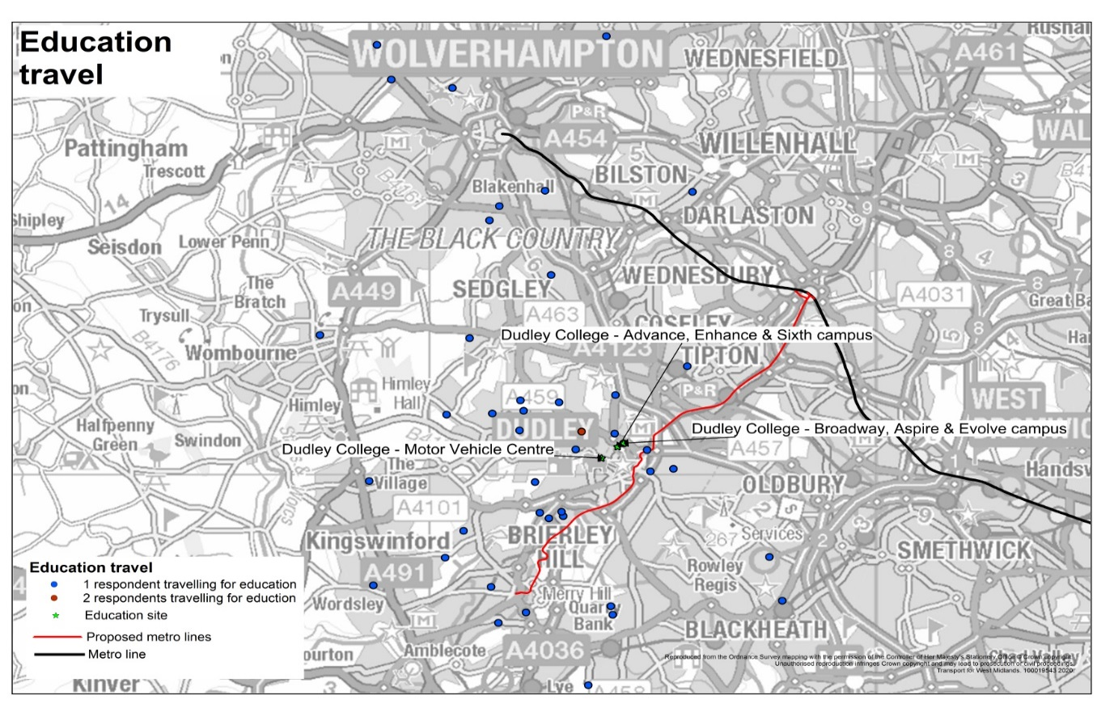

3.5.4 **Frequency of educational trips in/around Dudley Town Centre:** Respondents were asked how often they travel to their place of study around or through the Dudley Town Centre project area, **see Appendix 5b.**

* Just over a quarter (28%) travelled at least 5 days per week, while 58% travelled 2-4 days per week. 14% did so once per week and 1% doing so less often.

**Figure 8: Frequency Of Educational Journeys**

3.5.5 **Mode of travel when travelling for education:** Around three quarters (at 77%) of scholars travelled by bus, a much higher proportion than was found amongst commuters. Just 8% were either lone car drivers or car sharers.

* **Appendix 5c** and **Figure 9** looks at the place of educational establishment by mode of travel.
* Bus use appeared more common amongst journeys to Broadway, Aspire & Evolve and Advance, Enhance & Sixth campuses (85% and 71% respectively).
* Travelling by car was more common amongst scholars using the Motor Vehicle Centre Campus (lone car driver, 10%; car share, 30%) however the sample size across all locations (with the exception of Dudley College - Broadway, Aspire & Evolve campus) are low and results should be treated with caution.

**Figure 9: Mode Of Educational Travel (%)**

*Excludes low bases*

3.5.6 **Times of educational travel in the Dudley Town Centre Area:** Respondents were asked at what times they travel for study in/around Dudley Town Centre. **Table** **8** summarises the information while **Appendix 5d** gives further detail.

* In terms of the morning peak, 67% travelled between 08:00am to 09:30am, with a further 32% travelling before 8.00am.
* 43% travelled between 09:30am to 3:30pm, while slightly more (at 47%) travelled in the evening peak. Just 10% travelled after 06:00pm
* Due to low sample sizes caution is advised when looking at the data by mode, however there is some evidence that bus users travel earlier in the morning (before 08:00am) compared to car users.

**Table 8: Time Of Travel When Commuting In/Around Dudley Town Centre By Main Modes Of Travel (%)**

|  |  |  |  |  |
| --- | --- | --- | --- | --- |
|  | **Total** | **Car driver (lone)** | **Car Share** | **Bus** |
| Before 8:00 am | 32 | 0 | 0 | 40 |
| 8am up to 9:30am | 67 | 75 | 63 | 66 |
| 9:30am up to 3:30pm | 43 | 0 | 38 | 51 |
| 3:30pm up to 6pm | 47 | 13 | 63 | 51 |
| 6pm onwards | 10 | 38 | 0 | 9 |
| **Base** | **106** | **8** | **8** | **82** |

*% exceeds 100% due to multiple responses*

3.5.7 **Length of education trip:** On average education trips took 28 minutes 31 seconds, a slightly slower average travel time in comparison to work trips. **See Appendix 5e.**

* Bus trips tended to take the longest length of time (30 minutes: 49 seconds) compared to lone car journeys which took on average 20 minutes and 04 seconds and car share trips (average 17 minutes and 15 seconds).

**Figure 10: Average Travel Time To Education Trips By Main Modes Of Travel (min:sec)**

*Excludes low bases*

3.5.8 **Extra time allowed for congestion:** 58% of those making education trips allowed extra time due to congestion, while a further 25% said it varied. Only 16% did not allow extra time. **See Appendix 5f.**

* Collectively, respondents travelling by bus were most likely to allow extra travel time (65%).
* Fewer lone car drivers (50%) and car sharers (at 25%) allowed extra time.
* In terms of the amount of additional time allowed respondents most typically allowed between 11-20 minutes (28%) or less than 10 minutes (16%).

**Table 9: Extra Time Allowed Due To Congestion By Main Modes Of Travel (%)**

|  |  |  |  |  |
| --- | --- | --- | --- | --- |
|  | Total | Car driver (lone) | Car Share | Bus |
| **Yes allow extra time** | **58** | **50** | **25** | **65** |
| **Varies** | **25** | **25** | **25** | **25** |
| *Less than 10 minutes* | *16* | *13* | *25* | *16* |
| *11-20 minutes* | *28* | *25* | *0* | *33* |
| *21-30 minutes* | *5* | *0* | *0* | *6* |
| *Over 30 minutes* | *8* | *13* | *0* | *9* |
| *Varies* | *2* | *0* | *0* | *1* |
| **No did not allow extra time** | **16** | **25** | **50** | **10** |
| **Not applicable** | **1** | **0** | **0** | **0** |
| **Base** | **105** | **8** | **8** | **81** |

*Excludes low bases*

**3.6** **JOURNEYS FOR RELIGION/WORSHIP IN THE DUDLEY TOWN CENTRE AREA**

3.6.1 The 20 respondents who made religious trips were also asked to give additional details about the journeys they made in the Dudley Town Centre area.

3.6.2 **Journey origin of trips for worship:** **Figure 11** illustrates the journey origin of trips for worship.

* Respondents on religious trips were largely travelling from the DY2 9 Primrose Hill area or DY2 7 Dixons Green area. Fewer were travelling from the DY8 Stourbridge (postcode area).

**Figure 11: Journey Origin Education Trips**

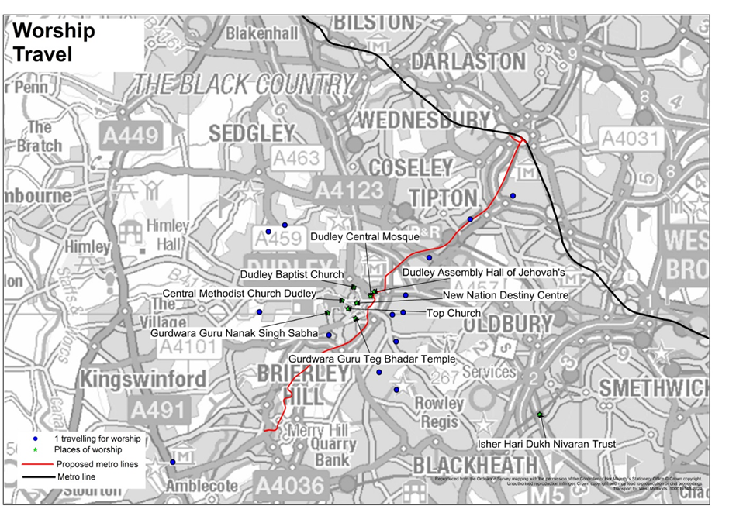

3.6.3 **Frequency of religious trips in/around Dudley Town Centre:** Respondents were asked how often they travel to their place of worship either around or through the Dudley Town Centre area.

* Those travelling for worship did so less frequently in comparison to both commuters and scholars, with just over a third travelling 2-4 days per week. Similar proportions travelled once per month/less often or once per week (25% each). Just 15% travelled at least 5 days per week. See **Appendix 6a and Figure 12**.

**Figure 12: Frequency Of Religious Journeys**

3.6.4 **Mode of travel when travelling for religious purposes:** Respondents were asked how they made their journeys of worship in and/or around Dudley Town Centre. Bus was the main mode used (at 37%), closely followed by car sharing (36%). 11% (2 respondents) equally walked or were lone car drivers. See **Appendix 6b and Figure 13**.

**Figure 13: Mode of Travel For Religious Trips**

3.6.5 **Times of religious travel in the Dudley Town Centre Area:** Respondents were asked at what times they travel for worship in/around Dudley Town Centre. **Table** **10** summarises the information while **Appendix 6c** gives further detail.

* 63% of those travelling for worship did so on a Sunday.
* However a significant proportion of religious trips occurred on weekdays between the hours of 09:30 to 16:00 (42%), and on a weekday evening after 18:00 (37%), an identical figure to those who travel for worship on a Saturday.

**Table 10: Time Of Travel For Worship In/Around Dudley Town Centre By Main Mode Of Travel (%)**

|  |  |  |  |
| --- | --- | --- | --- |
|  | **Total** | **Car share** | **Bus** |
| Weekday 7:30 to 9:30 | 21 | 14 | 43 |
| Weekday 0930 to 1600 | 42 | 29 | 57 |
| Weekday day 16:00 to 18:00 | 26 | 14 | 43 |
| Weekday evening after 18:00 | 37 | 29 | 43 |
| Saturday | 37 | 14 | 57 |
| Sunday | 63 | 71 | 57 |
| **Base** | **19** | **7** | **7** |

*% exceeds 100% due to multiple responses. Excludes low bases*

3.6.6 **Length of religious trip:** On average religious trips took 17 minutes 17 seconds, a shorter average journey time in comparison to both work and educational trips. **See Appendix 6d.**

* Bus trips took the longest (24 minutes: 56 seconds), with car share trips being amongst the shortest (12 minutes: 04 seconds).

**Figure 14: Average Travel Time Of Religious Trips By Main Mode Of Travel (min:sec)**

*Excludes low bases*

**3.7 TRAVELLING THROUGH JOURNEYS IN THE DUDLEY TOWN CENTRE AREA**

3.7.1 Overall, 160 people purely travelled through Dudley Town Centre (i.e. were not travelling to or from a location in the vicinity for any other purpose). These respondent were also asked to give additional details about these journeys.

3.7.2 **Journey origin of through trips:** **Figure 15** illustrates the journey origin of those travelling though Dudley Town Centre.

* There were significant proportions of people travelling from Brierley Hill, Woodside and Holly Hall areas.
* Respondents were also making journeys from the Wolverhampton and Sandwell areas with Sedgley, Coseley, Bilston and Tipton all being common journey origins.
* In addition there was also a substantial amount of people travelling through Dudley Town Centre from the Blackheath, Amblecote and Quarry Bank areas.

**Figure 15: Journey Origin Travelling Through Trips**

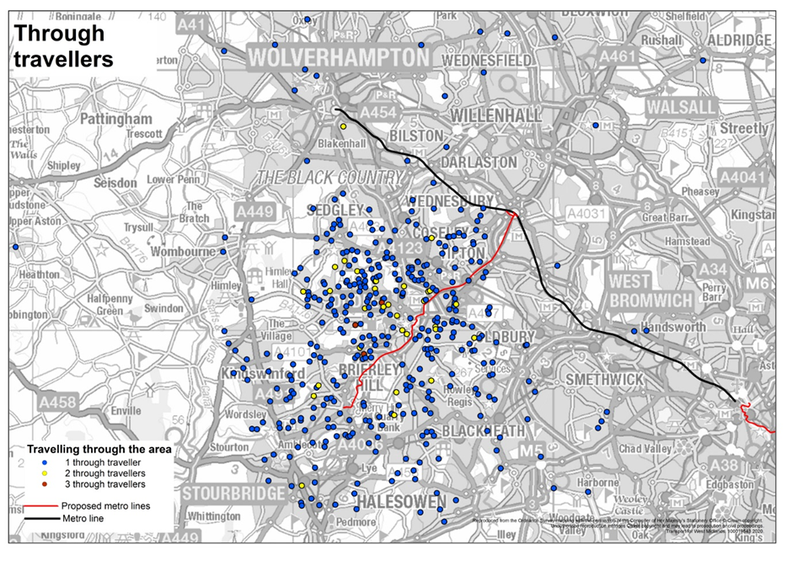

3.7.3 **Journey purpose of those travelling through:** The main reason for travelling through Dudley Town Centre was commuting (with 39%), while around a fifth (21%) were travelling to visit friend/relatives. 10% regularly travelled through for works related business. **See Appendix 7a and Table 11.**

**Table 11: Journey Purpose Summary And Detailed Responses**

|  |  |  |
| --- | --- | --- |
| **Journey Purpose Summary** | **Respondents** | **%** |
| Travelling to/from work | 63 | 39 |
| Visiting friends/relatives | 33 | 21 |
| Work's business | 16 | 10 |
| Other leisure/recreation | 15 | 9 |
| Shopping | 13 | 8 |
| Personal business | 10 | 6 |
| Study | 4 | 3 |
| Other | 6 | 4 |
| **Base** | **160** | **100** |

3.7.4 **Frequency of travelling through Dudley Town Centre:** Respondents were asked how often they travel through the Dudley Town Centre project area, **see Appendix 7b and Figure 16.**

* As one would expect due to the nature of the trips taken, around a third (32%) travelled at least 5 days per week, with equal shares of 34% travelling 2-4 days per week or once per week.
* Commuters travelled most frequently (67% 5 days per week), whilst those travelling to shop were more likely to travel through once per week (77%).

**Figure 16: Frequency Of Those Who Travel Through Journeys By Journey Purpose**

3.7.5 **Mode of travel when travelling through Dudley Town Centre:** Unsurprisingly, over two fifths of through traffic was made up of were lone car drivers (44%) or car sharers (with 28%). 23% travelled by bus. See **Appendix 7c**.

* Lone driving was more common amongst those travelling on works business (81%). It also accounted for 52% of those travelling to/from work, albeit, 32% from this subgroup also travelled by bus.

**Table 12: Mode Used When Travelling Through Travel By Main Journey Purpose (%)**

|  |  |  |  |  |  |
| --- | --- | --- | --- | --- | --- |
|  | Base | Travelling to/from work | Work's business | Visiting friends/relatives | Other leisure/recreation |
| Car driver (lone) | 44 | 52 | 81 | 36 | 47 |
| Car driver (with passenger) | 24 | 11 | 13 | 27 | 40 |
| Bus | 23 | 32 | 0 | 27 | 7 |
| Car passenger (dropped off) | 4 | 0 | 0 | 9 | 0 |
| Walk | 2 | 0 | 0 | 0 | 7 |
| Lorry/van | 1 | 2 | 6 | 0 | 0 |
| Rail | 1 | 2 | 0 | 0 | 0 |
| Cycle | 1 | 2 | 0 | 0 | 0 |
| **Total** | **160** | **63** | **16** | **33** | **15** |

*Excludes low bases*

3.7.6 **Times of travelling through Dudley Town Centre:** Respondents were asked at what times they travel through the Dudley area. **Table** **13** summarises the information while **Appendix 7d** gives further detail.

* Travelling through journeys hit a high during off peak hours of 09:30am up to 3:30pm (with 44%).
* 42% passed through during the afternoon peak hours of 03:30pm up to 06:00pm.
* 32% travelled before 08:00 and 24% between 08:00 up to 09:30.
* 41% of bus users travelled through Dudley Town Centre before 08:00am as did 38% of lone car drivers.

**Table 13: Time Of Travel When Travelling Through Dudley Town Centre By Work Place (%)**

|  |  |  |  |  |
| --- | --- | --- | --- | --- |
|  | **Total** | **Car driver (lone)** | **Car Share** | **Bus** |
| Before 8:00 am | 32 | 38 | 18 | 41 |
| 8am up to 9:30am | 24 | 30 | 16 | 22 |
| 9:30am up to 3:30pm | 44 | 39 | 47 | 49 |
| 3:30pm up to 6pm | 42 | 42 | 44 | 41 |
| 6pm onwards | 29 | 28 | 40 | 24 |
| **Base** | **160** | **71** | **45** | **37** |

*% exceeds 100% due to multiple responses. Excludes low bases*

**3.8** **SHOPPING AND LEISURE JOURNEYS IN DUDLEY TOWN CENTRE**

3.8.1 All respondents were asked if they made shopping and/or leisure trips in Dudley Town Centre. The sub-group of those who did were additionally asked to give similar details about the journeys they made in the Dudley Town Centre area.

3.8.2 **Frequency of shopping/leisure trips in Dudley Town Centre:** Respondents were asked how often they use Dudley Town Centre for either leisure and/or shopping, **see Appendices 8a, 8b and Figure 17.**

* **Shoppers:** Around a half (48%) of shoppers used Dudley Town Centre on a weekly basis, whilst similar proportions used the Town Centre monthly (17%) or less often (21%). 15% never use Dudley Town Centre to shop.
* **Leisure:** Fewer leisure users (at 24%) used Dudley Town Centre on a weekly basis, while 17% did so once a month and 30% less often. 29% never use Dudley Town Centre for leisure purposes.

**Figure 17: Frequency Of Shopping/Leisure Trips In Dudley Town Centre**

3.8.3 **Mode of travel when using Dudley Town Centre for shopping or leisure:** The subgroup of respondents who made shopping and/or leisure trips in Dudley Town Centre were further asked how they made those journeys. See **Appendices 8c and 8d.**

* **Shopping:** As **Figure 18** demonstrates, the main mode used by shoppers was car (29% car sharers and 22% lone car driver), albeit a large proportion travelled by bus (35%).
* **Leisure:** Those travelling for leisure largely mirrored shoppers with 36% being car sharers and 17% lone car drivers. 37% travelled to Dudley Town Centre by bus.

**Figure 18: Mode Used When Using Dudley Town Centre By Shoppers And Leisure Users (%)**

**3.9** **BUSINESSES WITHIN THE DUDLEY TOWN CENTRE AREA, POTENTIAL IMPACT OF THE PROJECT IMPROVEMENTS AND FURTHER CONSIDERATIONS**

3.9.1 **Organisation:** In total 26 businesses replied to the Dudley Town Centre survey, **Table 14** gives a full list of businesses, whilst **Table 15** summarises the nature of businesses who responded and the number of employees from each business that provided a response. See **Appendices 9a and 9b.**

**Table 14: Complete List Of Businesses**

|  |  |  |
| --- | --- | --- |
| **List of Business** | **Responses** | **%** |
| Dudley MBC | 3 | 12 |
| Dudley Canal and Tunnel Trust | 3 | 12 |
| Access in Dudley | 1 | 4 |
| Chaddesley Court | 1 | 4 |
| David's Cave 2 | 1 | 4 |
| Dudley College of Technology | 1 | 4 |
| DVC | 1 | 4 |
| DWP | 1 | 4 |
| Green Team Dudley | 1 | 4 |
| Innovise Ltd | 1 | 4 |
| National Express | 1 | 4 |
| New Path of life Cic | 1 | 4 |
| Sandwell TKD | 1 | 4 |
| Shipleys | 1 | 4 |
| Ye Olde Foundry | 1 | 4 |
| No reply | 7 | 27 |
| **Base** | **26** | **100** |

* 19% of businesses were classified as being Public Services (including Local Government), 15% as Health and 12% as Education.
* 44% businesses had over 100 employees while equal shares of 24% had less than 10 or between 10 and 50 employees.

**Table 15: Summary Of Business Nature And Number Of Employees**

|  |  |  |
| --- | --- | --- |
| **Nature of the Business** | **Respondents** | **%** |
| Public Services (including Local Government) | 5 | 19 |
| Health | 4 | 15 |
| Education | 3 | 12 |
| Wholesale and Retail sales | 2 | 8 |
| Accommodation and Hospitality | 2 | 8 |
| Professional services (e.g. lawyers, accountants, architects) | 2 | 8 |
| Information and Communication | 1 | 4 |
| Other | 7 | 26 |
| **Number Of Employees** |  | |
| Less than 10 | 6 | 24 |
| 10 – 50 | 6 | 24 |
| 51 – 100 | 2 | 8 |
| Over 100 | 11 | 44 |
| **Base** | **26** | **100** |

3.9.2 Businesses were further asked to rate the potential impact of the Dudley Town Centre project works on three aspects on their business on a scale of no/little impact to significant impact. The majority of businesses thought the works would have a significant impact.

* **Staff:** Half (50%) thought that the improvements works would have a significant impact on staff, whilst 27% felt it would have moderate impact.
* **Customer/Clients:** 64% believed that improvement works would have a significant impact on their customers and/or clients, whilst 23% felt they would have a moderate impact.
* **Freights/Logistics:** Fewer (at 37%) assumed that the improvement works would have a significant impact on the freight/logistics of their business, whilst just over a quarter (26%) felt it would have a moderate impact. See **Appendix 9d and Figure 19**.

**Figure 19: Potential Impact Of The Dudley Town Centre Project Activity On Businesses (%)**

* + 1. **Further Considerations:** Business respondents were finally asked if there was anything else that Dudley MBC and TfWM should consider in respect of the impact of the project activity on their respective business. Overall, 10 further comments were recorded. The main comment was *concern over the increase in congestion in/around the area* (3 comments, 30%). See **Appendix 9e and Table 16**.

**Table 16: Considerations For Dudley MBC And TfWM**

|  |  |  |
| --- | --- | --- |
|  | **Respondents** | **%** |
| Concerned over congestion/Local area (Oakham/Tansley Hill/Black Heath/Gornal/Sedgley/Wolverhampton to Birmingham) | 3 | 30 |
| Ensure signage for diversions are correct/Easy to read/Follow | 2 | 20 |
| Create park and ride/park and walk schemes | 2 | 20 |
| Concerned over the impact on clients/working relationships when they drive past the business/can't get to meetings | 2 | 20 |
| Other | 6 | 60 |
| **Base** | **10** | **150** |

*% exceeds 100 due to multiple responses/*Other consists of singular responses*

**3.10 CONSIDERED AND PROBABLE TRAVEL BEHAVIOUR CHANGES DURING THE DUDLEY TOWN CENTRE PROJECT WORKS**

3.10.1 To understand how people are prepared to change their journeys to help ease any traffic congestion that may occur as a result of the Dudley Town Centre project work, respondents were asked if they would consider a number of options and if so, what options they were most likely to take. These results can be compared to the reasons and the ways people currently travel to get a clear idea of the changes people are willing to make. **See Appendix 10a.**

* **Changes people may consider doing:** Respondents were shown a list of potential behavioural changes and asked which they may consider making. Overall the two most likely behavioural changes considered were *to change travel time to avoid the peak* or *take a different route* (31% each).
* 21% *would not consider* making any of the suggested changes.
* 18% would contemplate *walking or cycling more*, whilst 16% would *leave the car at home and travel using a different mode*.
* Fewer were interested in *working from home/alternative location* (14%), *car sharing* or were simply *unsure* (equally 13%).
* Just 3% would *seek information regarding cycling/cycle training*.

**Figure 20: Considered Behavioural Changes During The Project Work (%)**

*Exceeds 100% due to multiple responses*

* + 1. **Other actions respondents may consider taking:** Other actions people may consider taking to avoid the congestion around Dudley Town Centre were to:
* *Travel by car if one becomes available/pass their driving test* (9 people, 56%) or would *travel to another destination* (5 individuals, 31%).
* 2 individuals (6% each) would *park further out of town* or stated that *they would not be able to change their travel patterns due to shift work*. See **Appendix 10b** and **Table 17**.

**Table 17: Other Actions Respondents May Consider Taking As A Result Of The Project Works**

|  |  |  |
| --- | --- | --- |
|  | **Respondents** | **%** |
| Would use the car if it’s available/Car when pass my test | 9 | 56 |
| Would travel somewhere else | 5 | 31 |
| Would park further out of town | 1 | 6 |
| Would not be able to change due to shift patterns | 1 | 6 |
| **Base** | **16** | **100** |

* + 1. **Methods consider transferring to:** The subgroup of 163 respondents (15% of the overall sample) who stated that they might leave the car at home and travel using another mode were further asked what method they would consider.
* 73% (11% overall) would transfer to using the bus, whilst 52% (7% overall) would consider using tram.
* Similar proportions would use the train (34%; 5% of overall sample) or would consider walking (33%; 5% of the overall sample).
* Those travelling through the area were most likely to consider the tram; while irregular users of the Town Centre and commuters and were most likely to consider using the bus. Shoppers were more likely to consider walking. See **Table 18** and **Appendix 10c**.

**Table 18: Transferred Methods Of Transport (Considered %)**

*Asked of those who would consider change of mode:*

*Excludes small bases*

|  |  |  |  |  |  |
| --- | --- | --- | --- | --- | --- |
|  | **Total** | **Regular Commuter** | **Regular Shopper** | **Regularly Travelling Through** | **Irregular Travellers** |
| Bus | 73 | 73 | 71 | 67 | 77 |
| Tram | 52 | 55 | 44 | 68 | 52 |
| Train | 34 | 20 | 28 | 57 | 43 |
| Walk | 33 | 25 | 38 | 32 | 34 |
| Car share | 21 | 35 | 13 | 21 | 11 |
| Cycle | 18 | 10 | 23 | 14 | 30 |
| Taxi | 8 | 3 | 10 | 4 | 9 |
| Don't know | 3 | 3 | 3 | 0 | 5 |
| **Base** | **163** | **40** | **39** | **28** | **44** |

*% exceeds 100% due to multiple responses*

* + 1. **Most likely behavioural change:** Respondents were then asked what change they were **most** likely to make. The results largely mirrored those above with the main behavioural change being to *change travel time to avoid the peak* (at 28%) or to take a different route (26%).
* Fewer were interested in *walking or cycling more* (15*%), leaving their car at home and travelling by another mode* (11%), *car sharing* or *working from home/alternative location* (8% each).
* 2% were *unsure* of their potential actions whilst just 1% would *actively find out more about cycling/cycle training*. See **Appendix 10d and Figure 21**.

**Figure 21: Most Likely Behavioural Changes During Disruption (%)**

*Single responses*

* **Table 19** looks at the most probable behavioural changes by journey purpose and main mode as with considered changes.
* Re-timing was the most common behavioural change amongst travellers regardless of journey purpose, with the exception of those who simply travel through the area, who were most likely to re-route.
* Scholars and irregular travellers were the groups most like to re-time (equally with 33%).
* Shoppers were most likely to walk/cycle more (22%) in comparison to other groups.
* Irregular Dudley Town Centre users (16%) and those who regularly travel through the area (10%) were the only groups who gave priority to leaving their car at home and travel by using another method of transport.
* In terms of mode of travel, lone car drivers were most likely to re-route.
* Car sharers and bus users were more likely to re-time, particularly for trips to college and when shopping.

**Table 19: Main Potential Behavioural Changes By Journey Purpose And Main Mode Of travel (%)**

|  |  |  |  |  |
| --- | --- | --- | --- | --- |
|  | **All** | **Lone car drivers** | **Car sharers** | **Bus users** |
| **Regular Commuter** | | | | |
| Change the time of your journey (Re-Time) | 24 | 23 | 14 | 38 |
| Take a different route (Re-route) | 19 | 24 | 12 | 5 |
| Walk or cycle more | 19 | 9 | 23 | 33 |
| **Regular Scholar** | | | | |
| Change the time of your journey (Re-Time) | 33 | 25 | 37 | 33 |
| Take a different route (Re-route) | 22 | 13 | 21 | 23 |
| Walk or cycle more | 19 | 13 | 21 | 17 |
| **Regular Shoppers** | | | | |
| Change the time of your journey (Re-Time) | 32 | 24 | 36 | 34 |
| Take a different route (Re-route) | 23 | 39 | 25 | 17 |
| Walk or cycle more | 22 | 17 | 16 | 21 |
| **Regularly Travelling Through** | | | | |
| Take a different route (Re-route) | 51 | 54 | 51 | 48 |
| Change the time of your journey (Re-Time) | 19 | 16 | 21 | 19 |
| Leave the car at home (Re-mode) | 10 | 13 | 11 | 10 |
| **Irregular travellers in area** | | | | |
| Change the time of your journey (Re-Time) | 33 | 22 | 27 | 52 |
| Take a different route (Re-route) | 23 | 34 | 25 | 13 |
| Leave the car at home (Re-mode) | 16 | 20 | 16 | 11 |

*Excludes low bases*

* **Other actions most likely to make:** When asked what other actions respondents were **most** likely take in order to avoid the congestion in Dudley Town Centre, only 8 respondents gave a reply. **Table 20** summarises these responses. See **Appendix 10e**.

**Table 20: Other Actions Respondents May Take As A Result Of The Project Works**

|  |  |  |
| --- | --- | --- |
|  | **Respondents** | **%** |
| Would use public transport if possible | 3 | 38 |
| Would go somewhere else | 2 | 25 |
| Opening of tram will help/Will use the tram when available | 1 | 13 |
| Would park further out of the town | 1 | 13 |
| Would not be able to change the way I travel due to shift work | 1 | 13 |
| **Base** | **8** | **100** |

* + 1. **Methods most likely to transfer to:** The small subgroup of 78 respondents who were most likely to leave the car at home and travel using another mode were asked what mode they would transfer to. 49% would transfer to using the bus (3% from the overall sample), whilst 35% (2% from the overall sample) would use the tram. The reader should take note that the sample size is not robust enough to examine this data set by journey purpose or mode of travel. See **Table 21** and **Appendix 10f.**

**Table 21: Methods Most Likely To Transfer To**

|  |  |  |
| --- | --- | --- |
|  | **Respondents** | **%** |
| Bus | 39 | 49 |
| Tram | 27 | 35 |
| Train | 9 | 12 |
| Car share | 1 | 1 |
| Cycle | 1 | 1 |
| Don’t know | 1 | 1 |
| **Base** | **78** | **100** |

**3.11 AWARNESS OF THE PLANNED MAJOR PROJECTS AROUND DUDLEY**

3.11.1Respondents were asked about awareness of a number of major projects that are planned for Dudley. Four fifths (80%) of respondents were most aware of the *planned Midlands Metro tram extension running between Brierley Hill, Dudley, Wolverhampton and Birmingham,* this was followed by some distance by the *Black Country Living Museum expansion*, the *new Dudley Leisure Centre* and the *Dudley Transport Interchange* (48%, 45% and 37% respectively). Around a quarter were mindful of the *new Institute of Technology (IoT) at Castle Hill* (26%), *Portersfield* and the *Very Light Railway and Innovation Centre at Castle Hill* (equally with 25%). Fewer were aware of the *Autonomous vehicles demonstrator route* (14%). Just 12% were *unaware* of all of the regeneration projects. See **Appendix 11 and Table 22**.

* Awareness of the Midland Metro tram extension was high regardless of mode, reaching a high of 83% amongst both lone car drivers and car sharers.
* Awareness of the new Dudley Leisure Centre plans rose to 56% amongst walkers/cyclists.
* As one would expect bus users had the highest awareness levels of the Dudley Transport Interchange (44%). However this group had the lowest awareness levels for the Leisure Centre, the Institute of Technology, the Light Railway and the Autonomous vehicles demonstrator route.

**Table 22: Awareness Of The Dudley Regeneration Plans By Mode Of Travel (%)**

|  |  |  |  |  |  |
| --- | --- | --- | --- | --- | --- |
|  | Total | Lone car drivers | Car share | Bus users | Walkers/Cyclists |
| Midland Metro tram extension | 80 | 83 | 83 | 76 | 82 |
| Black Country Living Museum expansion | 48 | 51 | 53 | 43 | 53 |
| A new Dudley Leisure Centre on Flood Street Car Park | 45 | 51 | 53 | 39 | 56 |
| Dudley Transport Interchange: A combined Metro and Bus Interchange | 37 | 33 | 34 | 44 | 40 |
| Portersfield  -  Major Mixed-Use Development | 26 | 34 | 30 | 20 | 53 |
| A new Institute of Technology (IoT) at Castle Hill | 25 | 25 | 27 | 25 | 31 |
| Very Light Railway/Innovation Centre at Castle Hill | 25 | 31 | 29 | 21 | 39 |
| Autonomous vehicles demonstrator route | 14 | 17 | 15 | 11 | 26 |
| Unaware of all | 12 | 9 | 9 | 14 | 7 |
| **Base** | **1068** | **389** | **412** | **419** | **135** |

*Excludes low bases*

*Exceeds 100% due to multiple responses*

**3.12** **LIKELIHOOD OF USING THE NEW MIDLAND METRO ONCE WORK IS COMPLETE**

3.12.1 Respondents were told that it is estimated that by 2023 the Metro will run from Grand Central Birmingham and Wolverhampton via Wednesbury to Dudley Port, Dudley Town Centre, Merry Hill and Brierley Hill. They were then asked if they would consider using the Metro once the work is complete. Overall, almost three quarters (73%) would use the Metro. See **Appendix 12 and Table 23**.

* Bus users, along with walkers/cyclists (80% and 77% respectively) were most likely to use the Metro once work is complete.
* Likelihood of use dropped amongst lone car drivers (65%).

**Table 23: Likelihood Of New Station Use By Main Mode Of Travel (%)**

|  |  |  |  |  |  |
| --- | --- | --- | --- | --- | --- |
|  | Total | Lone car drivers | Car share | Bus users | Walkers/Cyclists |
| Yes | 73 | 65 | 71 | 80 | 77 |
| No | 11 | 17 | 13 | 6 | 10 |
| Unsure | 16 | 19 | 16 | 14 | 13 |
| **Base** | **1029** | **390** | **421** | **422** | **136** |

*Excludes low bases and no replies*

**3.13 TRAVEL INFORMATION SOURCE(S) USED**

3.13.1 Dudley Town Centre users were asked which information sources they used to gain information about their local journeys, roadworks and/or delays. The main response by some distance was the internet/online (62%). Around a third (34%) use Mobile Apps or 31% Facebook. 24% listen to local radio, 22% revert to word of mouth and a fifth (20%) use their sat navs. Fewer use Twitter, paper timetables/maps or look at email updates (14%, 10% and 8% respectively). See **Appendix 13**.

* The internet/online was the most common source of information regardless of mode of travel or journey purpose.
* Lone car drivers had higher levels of local radio (35%) and sat nav use (32%).
* Those reliant on bus services had higher levels of use of mobile apps (47%), Facebook, Twitter (35% and 15% respectively) and paper timetables/maps (16%).
* A quarter of walkers/cyclists relied on word of mouth.

**Table 24: Information Source Used To Gain Information On Local Journeys, Roadworks And Delays By Mode Of Travel (%)**

|  |  |  |  |  |  |
| --- | --- | --- | --- | --- | --- |
|  | Total | Lone car drivers | Car share | Bus users | Walkers/Cyclists |
| Internet/online | 62 | 62 | 63 | 64 | 68 |
| Mobile Apps | 34 | 24 | 33 | 47 | 31 |
| Facebook | 31 | 27 | 29 | 35 | 27 |
| Local radio | 24 | 35 | 28 | 13 | 26 |
| Word of mouth | 22 | 24 | 24 | 18 | 25 |
| Sat nav | 20 | 32 | 24 | 6 | 30 |
| Twitter | 14 | 14 | 12 | 15 | 14 |
| Paper timetables/maps | 10 | 5 | 8 | 16 | 13 |
| Email updates | 8 | 7 | 7 | 10 | 7 |
| Don't refer | 5 | 6 | 6 | 5 | 4 |
| **Base** | **1026** | **389** | **421** | **419** | **136** |

*Exceeds 100% due to multiple responses*

3.14 **FURTHER SUGGESTIONS TO IMPROVE JOURNEYS IN THE DUDLEY TOWN CENTRE AREA**

3.14.1 Respondents were finally asked if they had any further suggestion to make to improve journeys in the Dudley Town Centre area. In total 428 respondents made a further comment. The main responses are summarised in the **Table 25** below, while **Appendix 14** provide further detail.

* The main response was a request to improve *bus reliability/stick to timetables* (25%).
* 18% wished for improved *bus service frequency* within the Dudley area.
* 14% raised concerns over *very poor traffic control in the area resulting in increase in traffic/congestion/gridlock.*
* 11% asked for *increased/cheaper/free car parking in the area.*
* A further 7% equally would like to see the implementation of *more direct bus services from Dudley Town Centre feeding the surrounding areas* or called for the Tram/Metro *work be done/completed quickly and efficiently.*

**Table 25: Suggested Improvements For Travel In The Dudley Area**

|  |  |  |
| --- | --- | --- |
|  | **Respondents** | **%** |
| Improve bus reliability/Stick to timetables/Turn up | 106 | 25 |
| Improve bus frequency/More frequent in Dudley buses needed | 79 | 18 |
| Improve very poor traffic control/Gridlocked/Congestion | 28 | 14 |
| Improve/Increase/Cheaper/Free car parking in the centre | 46 | 11 |
| More direct bus services needed | 31 | 7 |
| Ensure the tram/metro work is completed quickly/efficiently | 28 | 7 |
| Revitalise/Improve the look of Dudley | 22 | 5 |
| Bring back/Re-instate a train link to Dudley/Heavy rail line | 21 | 5 |
| More shops/bigger stores/Restaurants/Eateries/Cafes needed in Dudley | 20 | 5 |
| Improve interchange options/Buses should feed more rail stations | 20 | 5 |
| Cheaper bus fares/Cheaper public transport | 19 | 4 |
| Stop illegal parking/Traffic Wardens/Tickets needed for cars who park on double yellow lines/Poor parking at schools | 16 | 4 |
| Expand Roads/Expand road capacity on non primary routes/Have filter lanes | 15 | 4 |
| Feel unsafe when using the Bus Station/Beggars in Bus Station/Anti-social behaviour | 15 | 4 |
| More cycle friendly road/path access/Improve cycle infrastructure | 14 | 3 |
| All work to take place during the night/Limit the disruption/Out of peak hours | 13 | 3 |
| Have more police in the town centre/Make the town centre safer | 11 | 3 |
| Complete on-going works in the area 1st/Do work in sections | 11 | 3 |
| Improve cleanliness/facilities/toilets in the bus station | 10 | 2 |
| Pedestrianise the town centre/High street/Make sure pedestrians are safe | 10 | 2 |
| Bus App/NWM App/RTI always incorrect/Not reliable | 10 | 2 |
| Advertise/Publicise road closures early/Keep up communications/Social Media updates | 9 | 2 |
| Re-instate old services/routes (no.X7) | 8 | 2 |
| Get rid of the traffic island in the area/Have Junctions with lights like at Castle Gate/No islands/Round-Abouts | 7 | 2 |
| Move the zebra crossings/traffic lights near Dudley college/Priory as unsafe for students and cause traffic | 7 | 2 |
| Later/Earlier running bus services/Night/Sunday buses | 7 | 2 |
| Clearer way finding/Screens/Assisted Screens in Dudley/Bus station/Talking newspapers | 7 | 2 |
| Buses are old/Unclean/Smell/Dirty/cold/Improve buses | 7 | 2 |
| *Other | 78 | 18 |
| **Base** | **428** | **165** |

*% exceeds 100% due to multiple responses*

*\*Other consists of singular responses*

4.0 **CONCLUSION**

4.1 The survey provides a robust picture of Dudley Town Centre users. Users were largely car based travellers, albeit there was also a key group of bus users. Respondents were largely travelling to the Dudley Town Centre area for work purposes or were just simply travelling through the vicinity. These journeys tended to be made in the peak, particularly the morning peak. Fewer respondents were making education or religious trips, however a significant proportion of respondents made trips for shopping/leisure, although on a less regular basis. Unfortunately, when travelling by bus respondents recorded significantly longer journey times than any other modes.

4.2 Congestion in the area is clearly an issue with over half of commuters and scholars already allowing extra travel time due it. In terms of the behavioural changes respondents were most likely make in order to avoid any disruption caused by the planned projects was to *travel at a different time*. Re-timing was the most common response, particularly scholars and bus users. Re-routing closely followed with a similar proportion of respondents stating that they would take a different route to avoid congestion, this was most popular amongst commuters and lone car drivers. Few would consider walking/cycling more, re-moding, car sharing or working from home/alternative location.

4.3 Encouragingly, the majority of respondents were aware of the new Midland Metro tram extension, the Black Country Living Museum expansion and the plans for the new Dudley Leisure Centre on Flood Street Car Park. Fewer knew of the pans for the Autonomous vehicles demonstrator route. Potential Midland Metro usage once work is complete was high, albeit dipped amongst lone car drivers. Further suggestions as to how journeys in/around the Dudley Town Centre area could be improved included *improvements to both bus service reliability and frequency.* There were also *calls for enhancements to poor traffic control which already causes congestion/gridlock within the local area.*

4.4 In terms of getting disruption messages across, the internet was the most widely used source of travel information amongst all groups of respondents. Car users had the highest level of local radio and sat nav use, while those reliant on buses had a higher level of mobile app, Facebook, Twitter and paper timetable/map use.

4.5 The survey has provided an illustration of the challenges facing the Network Resilience team in encouraging behavioural change amongst Dudley Town Centre users, with many respondents reliant on the car and already familiar with dealing with congestion on their journeys. The bus in particular could be a less attractive alternative to car users with its longer journey times for the majority of journeys. It is perhaps therefore unsurprisingly that for most the easiest alternative was to simply either re-time or re-route their trips, albeit there were pockets of people who could be encouraged to walk/cycle more or to re-mode, leaving their car at home. Future research should be considered to monitor any changes made by users during the planned project disruption and whether these have any long term effects on their travel patterns.